Architecture Design

Expenditure Data Analysis

|  |  |
| --- | --- |
| **Written By** | Adil Shaikh |
| **Document Version** | 0.3 |
| **Last Revised Date** |  |

# DOCUMENT CONTROL

**Change Record:**

|  |  |  |  |
| --- | --- | --- | --- |
| **VERSION** | **DATE** | **AUTHOR** | **COMMENTS** |
| 0.1 | 23- Oct - 2021 | Adil Shaikh | Introduction and architecture defined |
| 0.2 | 24- Oct - 2021 | Adil Shaikh | Architecture & Architecture description appended and updated. |
| 0.3 | 25-Oct-2021 | Adil Shaikh | Deployment Options |
|  |  |  |  |

**Reviews:**

|  |  |  |  |  |  |  |  |  |
| --- | --- | --- | --- | --- | --- | --- | --- | --- |
| **VERSION** | **DATE** |  | **REVIEWER** |  | **COMMENTS** | | |  |
| 0.2 | 25- May -  2021 |  | Adil Shaikh |  | Server Architecture | | |  |
| **Approval Status:** | |  |  |  |  | | |  |
| **VERSION** | **REVIEW DATE** |  | **REVIEWED BY** |  |  | **APPROVED BY** |  | **COMMENTS** |
|  |  |  | |  | |  |  | |

# Contents

|  |  |  |
| --- | --- | --- |
| 1 | **Introduction** | 04 |
|  | **1.1 What is Architecture Design Document?** | 04 |
|  | **1.2 Scope** | 04 |
| 2 | **Architecture** | 05 |
|  | **2.1 Power Query** | 06 |
|  | **2.2 Power Query** | 06 |
|  | **2.3 Power View** | 06 |
|  | **2.4 Power Map** | 06 |
|  | **2.5 Power BI Desktop** | 07 |
| 3 | **Deployment** | 08 |
|  | **3.1 Deployment Options in Power BI** | 08 |

# 1. Introduction

**1.1 What is Architecture design document?**

Any software needs the architectural design to represents the design of software. IEEE defines architectural design as “the process of defining a collection of hardware and software components and their interfaces to establish the framework for the development of a computer system.” The software that is built for computer-based systems can exhibit one of these many architectures.

Each style will describe a system category that consists of :

* A set of components (eg: a database, computational modules) that will perform a function required by the system.
* The set of connectors will help in coordination, communication, and cooperation between the components.
* Conditions that how components can be integrated to form the system.
* Semantic models that help the designer to understand the overall properties of the system.

## 1.2 Scope

Architecture Design Document (ADD) is an architecture design process that follows a step-by-step refinement process. The process can be used for designing data structures, required software architecture, source code and ultimately, performance algorithms. Overall, the design principles may be defined during requirement analysis and then refined during architectural design work.

# 2. Architecture

* **PowerBI Server Architecture**

PowerBI has a highly scalable, n-tier client-server architecture that serves mobile clients, web clients and desktop-installed software. Tableau Server architecture supports fast and flexible deployments.

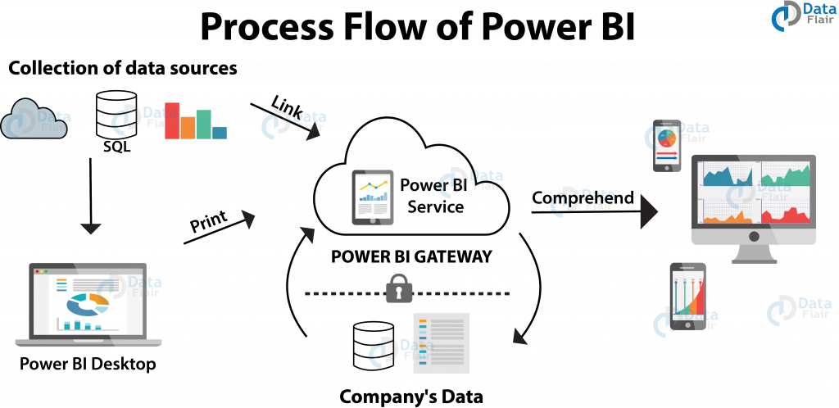

The following diagram shows PowerBI Server’s architecture:

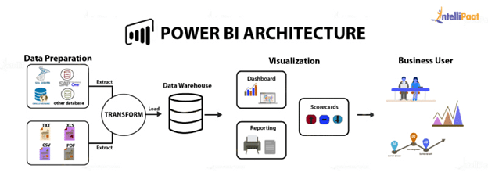

Tableau Server is internally managed by the multiple server processes.

**1) Power Query**

Power Query is the data transformation and mash up the engine. It enables you to discover, connect, combine, and refine data sources to meet your analysis need. It can be downloaded as an add-in for Excel or can be used as part of the Power BI Desktop.

## 2) Power Pivot

Power Pivot is a data modeling technique that lets you create data models, establish relationships, and create calculations. It uses Data Analysis Expression (DAX) language to model simple and complex data.

3) **Power View**

## Power View is a technology that is available in Excel, Sharepoint, SQL Server, and Power BI. It lets you create interactive charts, graphs, maps, and other visuals that bring your data to life. It can connect to data sources and filter data for each data visualization element or the entire report.

### 4) **Power Map**

Microsoft's Power Map for Excel and Power BI is a 3-D data visualization tool that lets you map your data and plot more than a million rows of data visually on Bing maps in 3-D format from an Excel table or Data Model in Excel. Power Map works with Bing maps to get the best visualization based on latitude, longitude, or country, state, city, and street address information.

### **5) Power BI Desktop**

Power BI Desktop is a development tool for Power Query, Power Pivot, and Power View. With Power BI Desktop, you have everything under the same solution, and it is easier to develop BI and data analysis experience.

.

**3. Deployment Description**

## 3.1 Deployment options in Power BI

Power BI analytics platform offers three different deployment options depending on your environment and needs. The below graphic shows each option at a glance:

There are three main deployment options when considering Power BI.

* The first is using the cloud **Power BI Service**[powerbi**.**com](https://powerbi.microsoft.com/en-us/), the most common option, which provides a full reporting solution hosted online
* The second is using **Power BI Report Server**, an on-premises solution like the online service but allowing you to manage Power BI yourself, a common scenario for customers with strict security requirements.
* The final solution is using **Power BI Embedded** which is used alongside the powerbi.com service to embed reports within applications via APIs.

.

.